Name: A. Abhishek Reddy
Rg no:192424192
DATE:13/7/2026
1.mapping color
A. CODE
library(ggplot2)
ggplot(mtcars, aes(x = wt, y = mpg, color = factor(gear))) +
geom_point(size = 3)
OUTPUT:
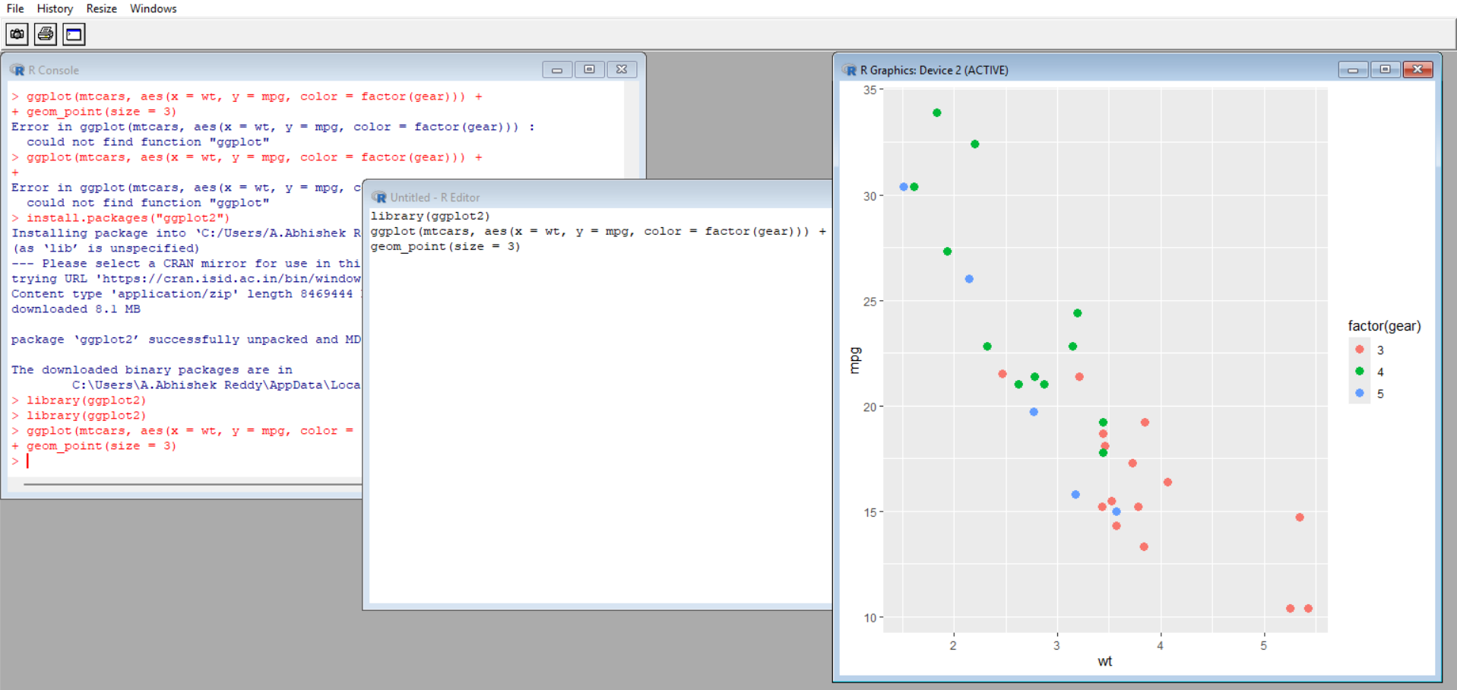
2.Continuous example:
Code:
library(ggplot2)
ggplot(mtcars, aes(x = wt, y = mpg, size = hp)) +
geom_point(alpha = 0.6)
OUTPUT:
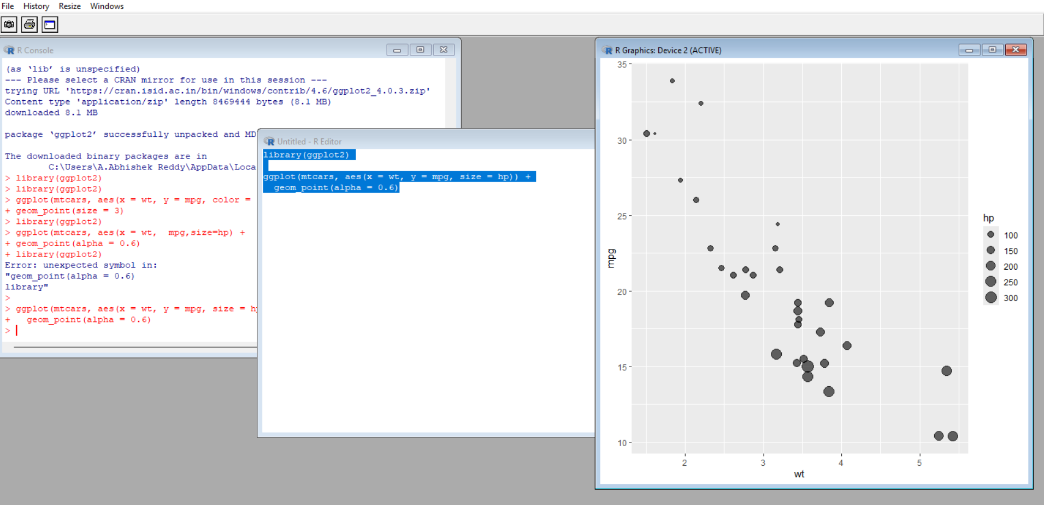
3.modify color size
Code:
library(ggplot2)
ggplot(mtcars, aes(x = wt, y = mpg, color = hp)) +
geom_point(size = 3)+
scale_color_gradient(low="blue",high="red")
OUTPUT:
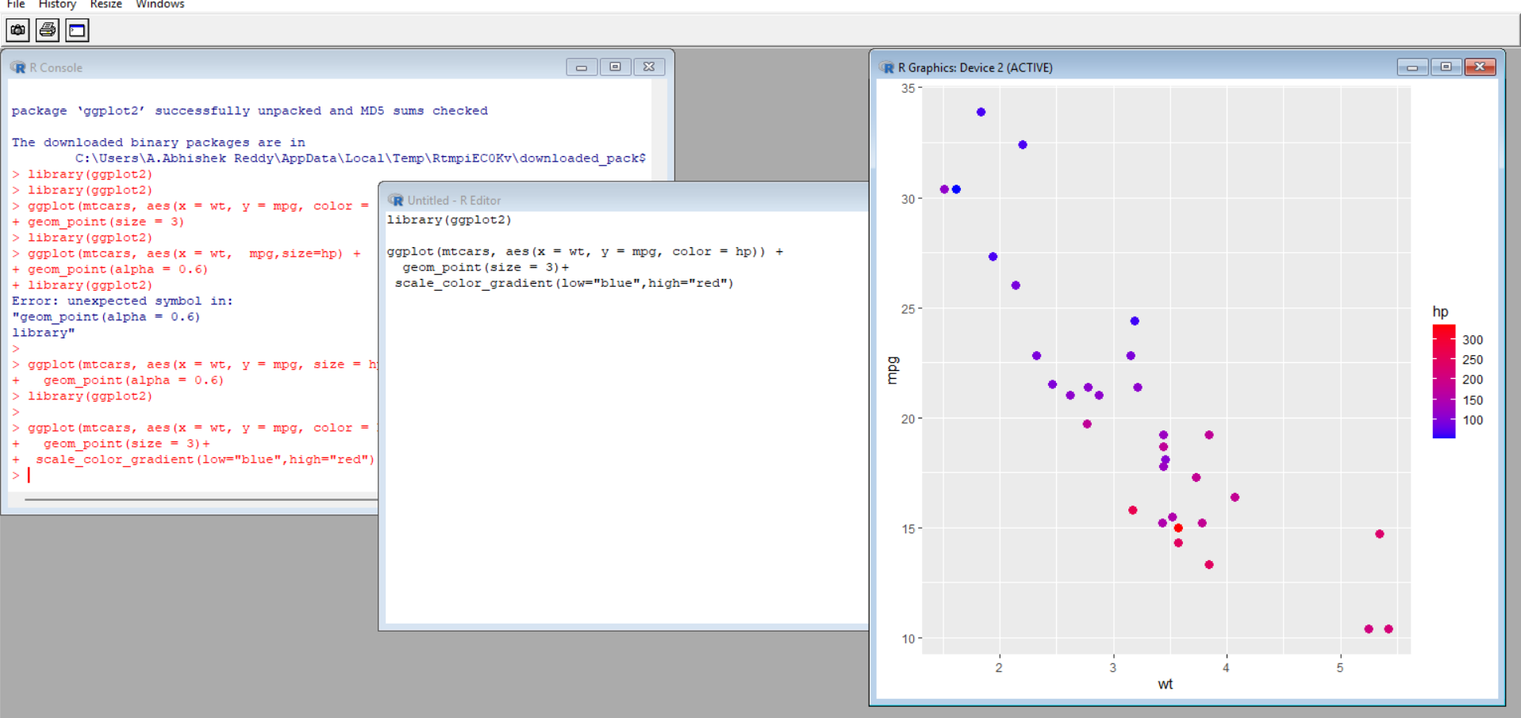
4.categorial example:
Code:
library(ggplot2)
ggplot(mtcars, aes(x = wt, y = mpg, color = factor(gear))) +
geom_point(size = 3)
OUTPUT:
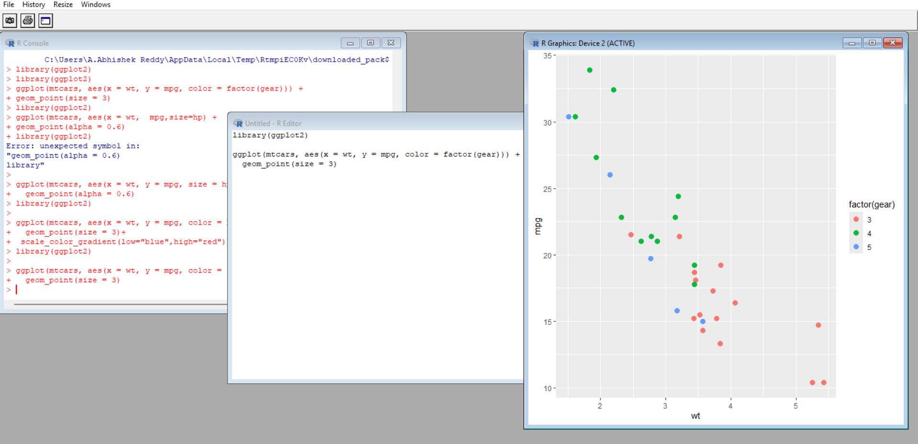
5.custom breaks
Code:
library(ggplot2)
ggplot(mtcars, aes(x = wt, y = mpg)) +
geom_point() +
scale_x_continuous(breaks = seq(1, 6, 1))
Output:
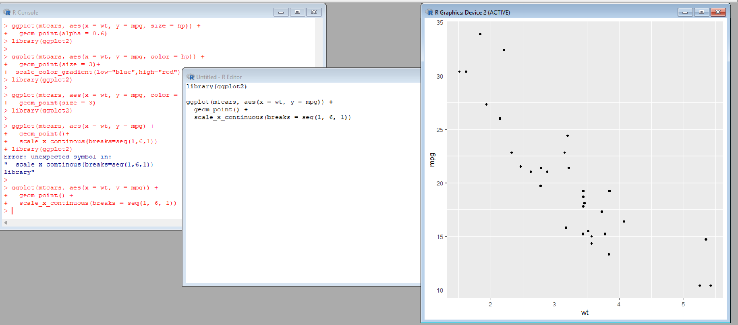
6.cartesian coordinates
Code:
library(ggplot2)
ggplot(mtcars, aes(x = wt, y = mpg)) +
geom_point() +
coord_cartesian(xlim = c(2, 5))
Output:
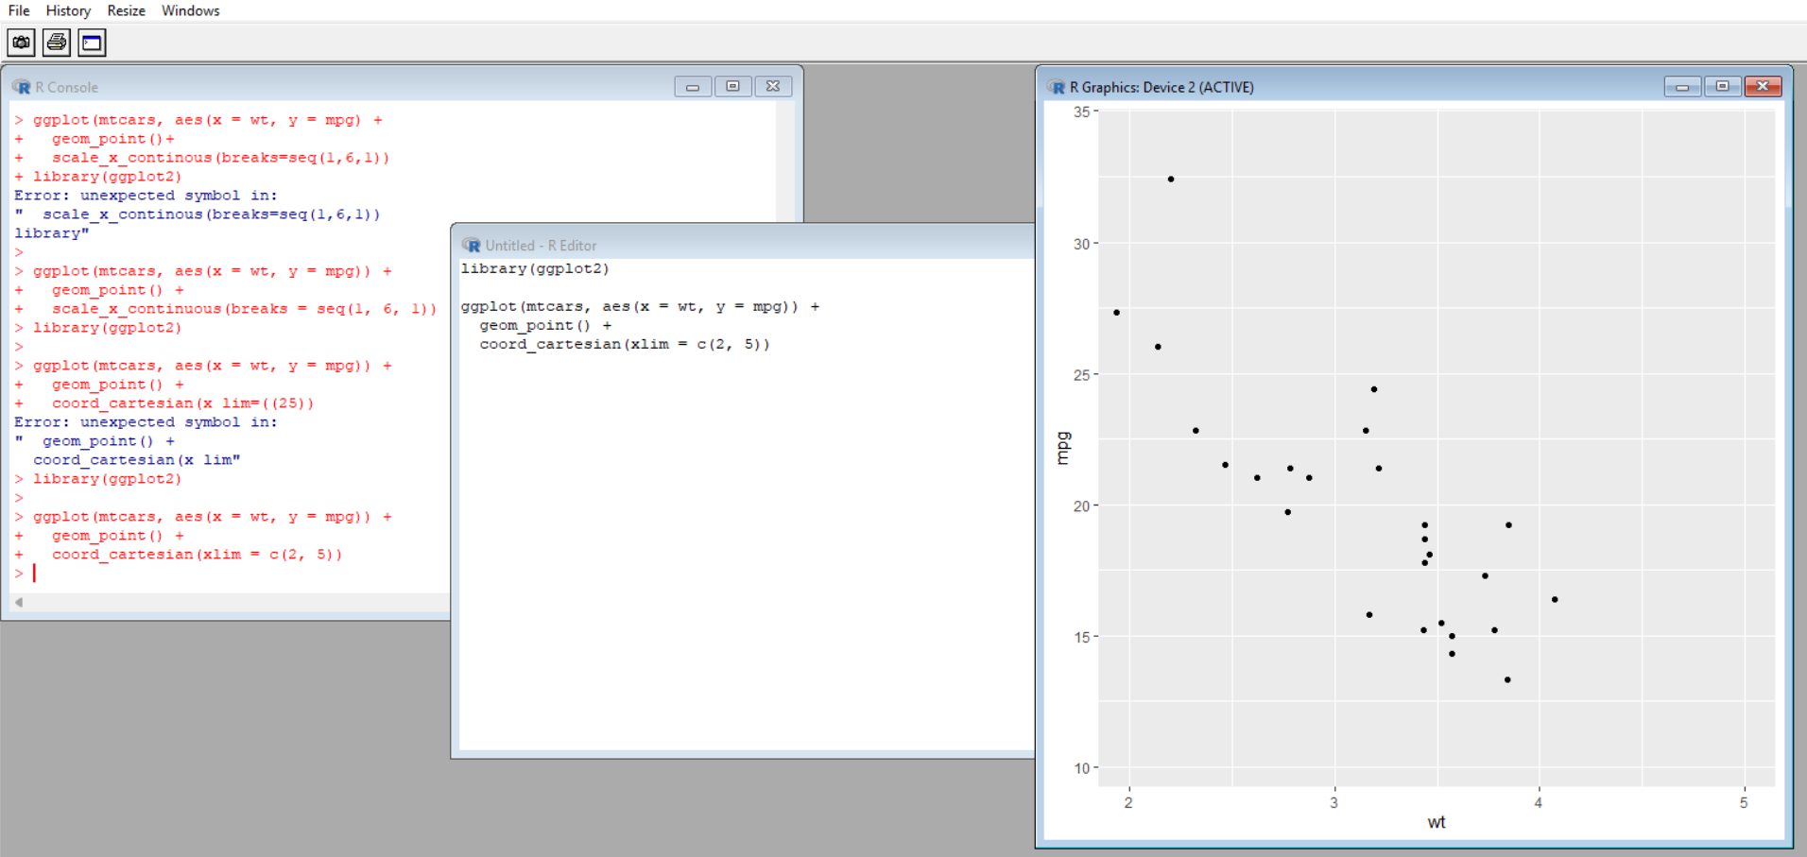
7.log scale
Code:
library(ggplot2)
ggplot(mtcars, aes(x = wt, y = mpg)) +
geom_point() +
scale_y_log10()
Output:
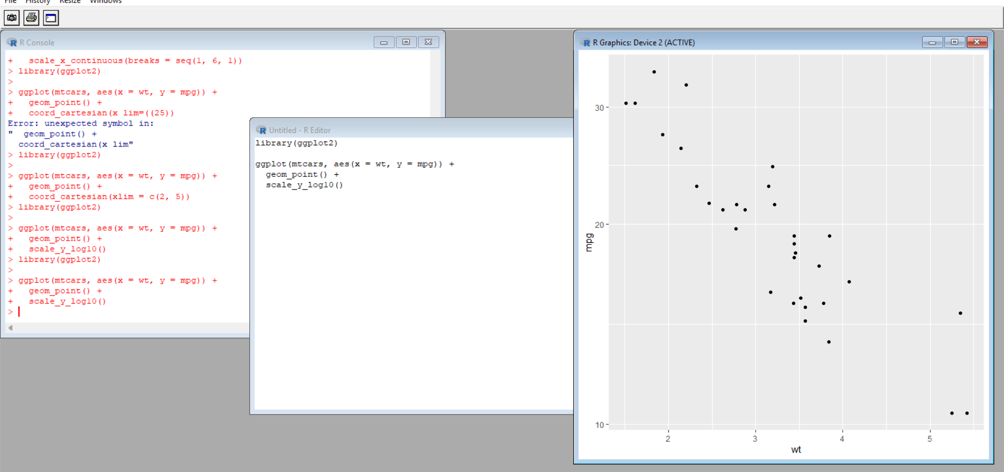
8.polar coordinates
Code:
library(ggplot2)
ggplot(mtcars, aes(x = factor(cyl))) +
geom_bar() +
coord_polar()
Output:
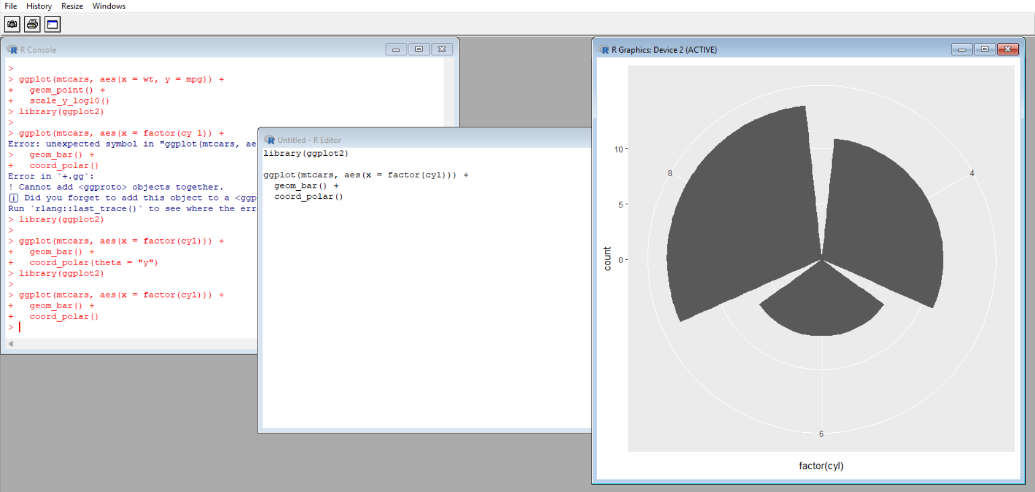
9.sequential color
Code:
library(ggplot2)
ggplot(mtcars, aes(x = wt, y = mpg, color = hp)) +
geom_point(size = 3) +
scale_color_viridis_c()
Output:
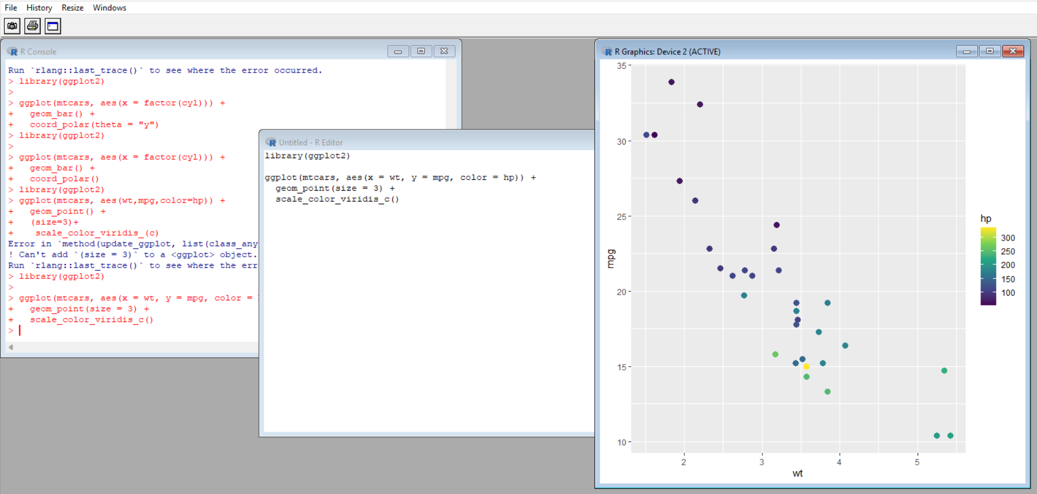
10.Diverging color
library(ggplot2)
ggplot(mtcars, aes(x = wt, y = mpg, color = mpg-mean(mpg))) +
geom_point(size = 3) +
scale_color_gradient2(low="blue",mid="white",high="red")
Output:
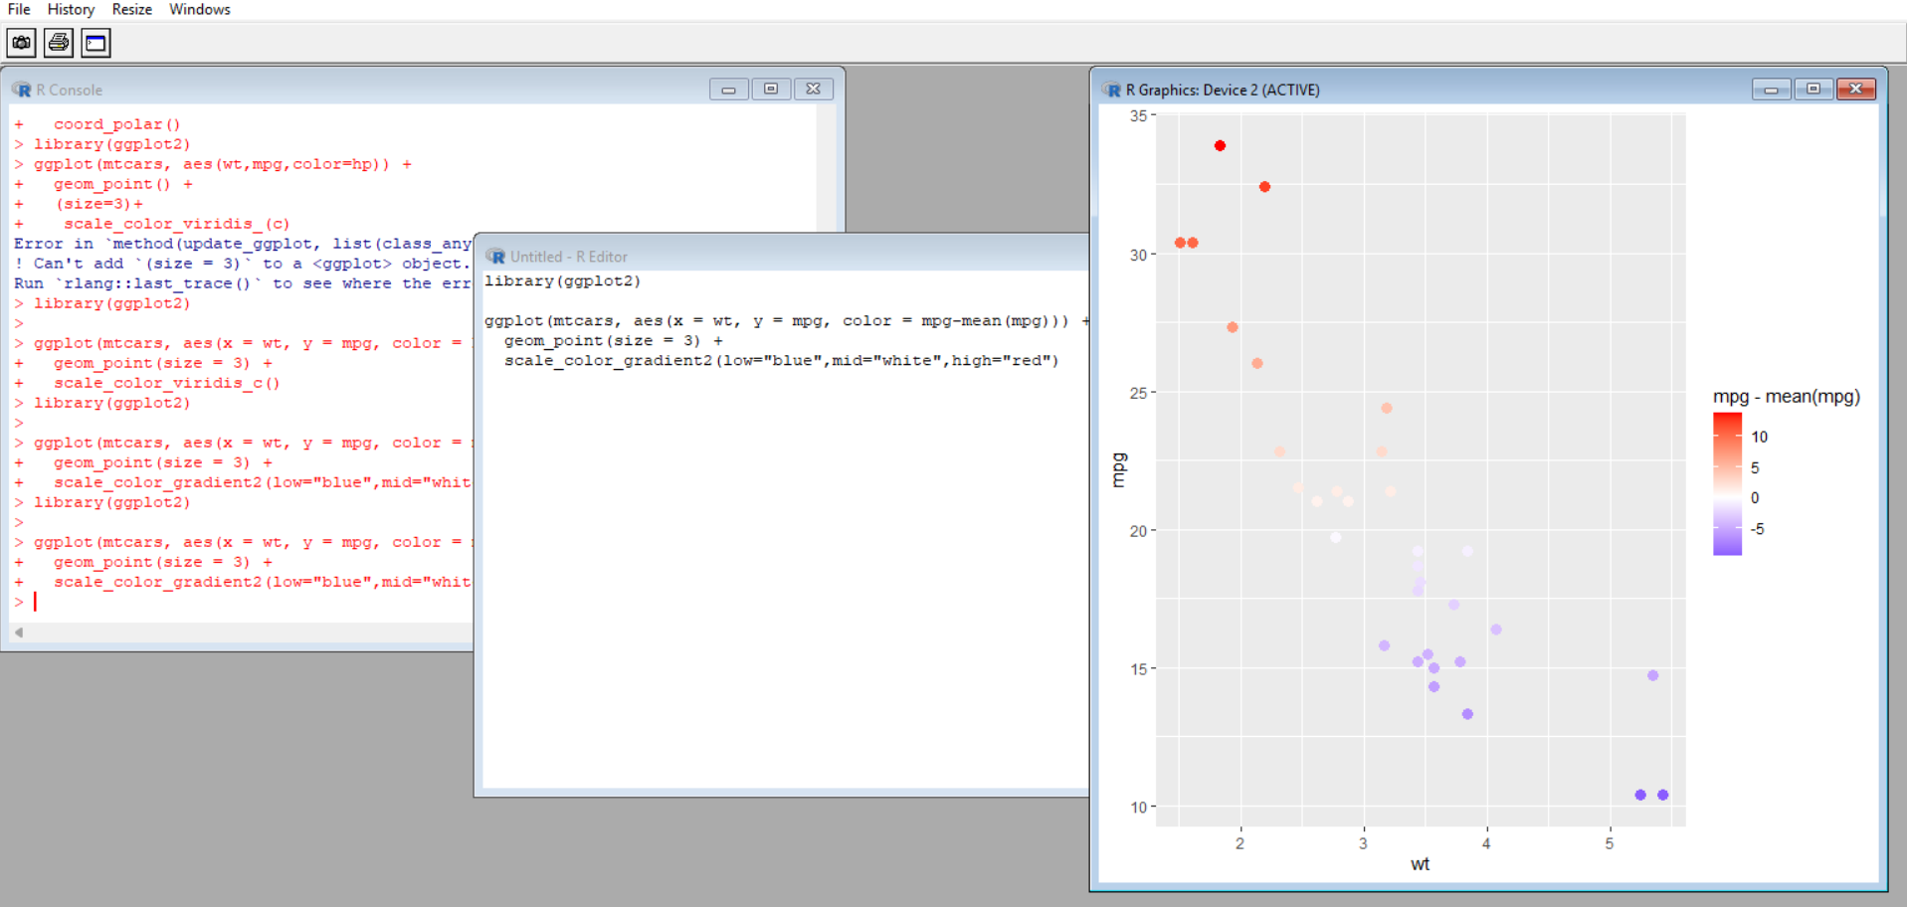
11.color as a tool to distinguish
Code:
Code:
library(ggplot2)
ggplot(mtcars, aes(wt,mpg,color = factor(cyl))) +
geom_point(size=3)
Output:
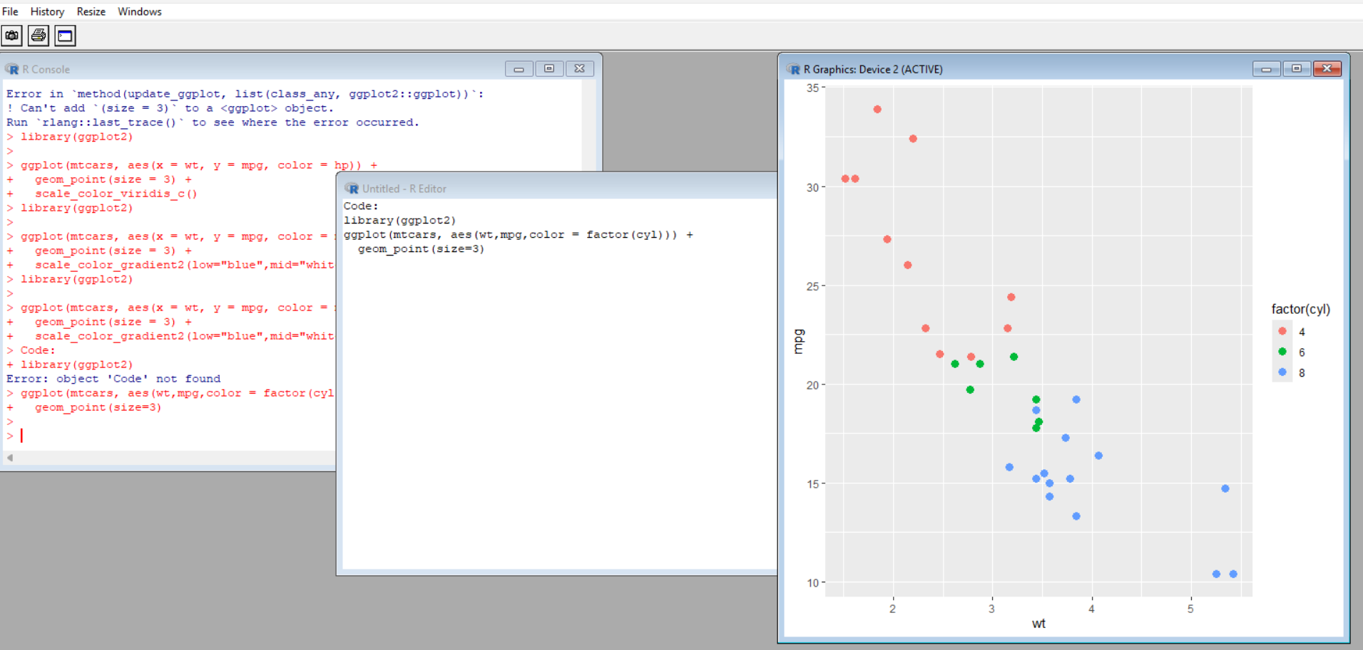
12.non-linear axis:
Code:
library(ggplot2)
ggplot(mtcars, aes(wt, mpg)) +
geom_point() +
scale_x_log10() +
scale_y_log10()
Output:
